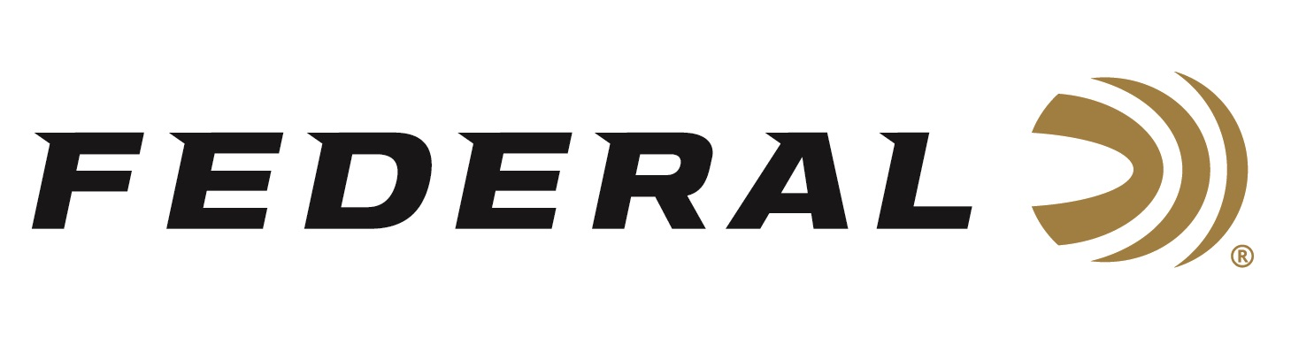

FOR IMMEDIATE RELEASE

Federal Sponsored Shooters Shine at Spring Grand

ANOKA, Minnesota – February 24, 2021 – Team Federal congratulates one of its newest members, Payton Detavernier, as she claimed the Lady 1 Singles Championship at the Spring Grand in Tucson, Arizona. Detavernier, a Nebraska native, bested a field of fifty-one competitors in her Team Federal debut. Detavernier shot an impressive score of 199 out of 200 using Federal’s Top Gun 1 1/8-ounce loads.

“I am so excited to be a part of this amazing team and so ready to kick off this new target year,” said Detavernier, a college student at Doane University in Nebraska. “I believe that Federal Ammunition is the best ammunition for me, and I believe this is a big step in my career,” stated Detavernier.

Also turning in a strong performance was Utah native Grayson Stuart. Stuart finished in second place in the Junior 1 category with a 198 out of 200 narrowly missing the top spot by just one clay target. Stuart finished runner-up for High Over All in the Junior 1 category to complete a fantastic week of trap shooting competition.

Competing in the Handicap Championship, Team Federal’s Aaron Willoughby finished third out of 545 competitors in the event and was the winner of the Hall of Fame Contributor Award Trophy. The Kentucky native missed part of the competition due to weather and flight cancellations but says, “it was a good start for sure despite the travel difficulties.” Willoughby’s choice of loads is Gold Medal Grand Paper when shooting from 27 yards. “This sets me up for the Southern Grand coming up in March,” says Willoughby, where he has enjoyed success at the Silver Dollar Shooters Club.

Other Team Federal shooters that participated at the Spring Grand include Greg Ferguson, who finished fifth in the Handicap Championship and Ray Stafford, who won the Senior Vet Singles Championship in a shoot off.

Federal ammunition can be found at dealers nationwide or purchased online direct. For more on Federal ammunition, visit www.federalpremium.com.

Press Release Contact: JJ Reich
Senior Manager – Press Relations
E-mail: VistaPressroom@VistaOutdoor.com

About Federal Ammunition
Federal, headquartered in Anoka, MN, is a brand of Vista Outdoor Inc., an outdoor sports and recreation company. From humble beginnings nestled among the lakes and woods of Minnesota, Federal Ammunition has evolved into one of the world's largest producers of sporting ammunition. Beginning in 1922, founding president, Charles L. Horn, paved the way for our success. Today, Federal carries on Horn's vision for quality products and service with the next generation of outdoorsmen and women. We maintain our position as experts in the science of ammunition production. Every day we manufacture products to enhance our customers' shooting experience while partnering with the conservation organizations that protect and support our outdoor heritage. We offer thousands of options in our Federal Premium and Federal® lines-it's what makes us the most complete ammunition company in the business and provides our customers with a choice no matter their pursuit.

